**AWS TASKS**

1. Launch one EC2 using Amazon Linux 2 image and add a script in user data to install Apache.

**Step 2: User Data Script (for Apache Installation)**

#!/bin/bash

# Update packages

dnf update -y

# Install Apache (httpd)

dnf install -y httpd

# Start Apache service

systemctl start httpd

# Enable Apache to start on boot

systemctl enable httpd

# Add a simple index.html page

echo "<h1>Welcome to Amazon Linux 2023 EC2 with Apache</h1>" > /var/www/html/index.html

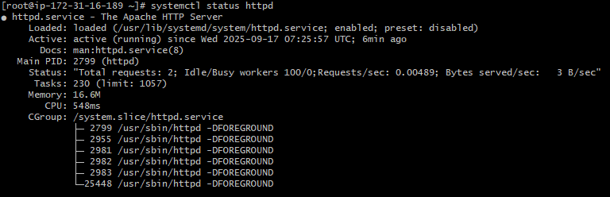

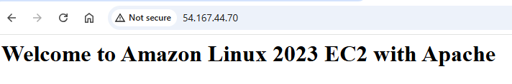

**Launch one EC2 using Ubuntu image and add a script in user data to install Nginx?**

#!/bin/bash

# Update package list

apt update -y

# Install Nginx

apt install -y nginx

# Start Nginx service

systemctl start nginx

# Enable Nginx to start on boot

systemctl enable nginx

# Add a simple index.html page

echo "<h1>Welcome to Ubuntu EC2 with Nginx</h1>" > /var/www/html/index.nginx-debian.html

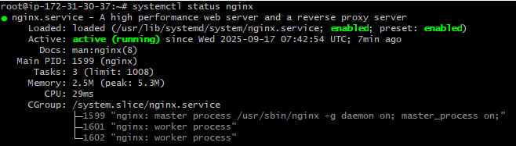

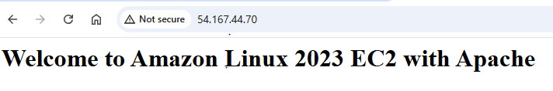

**Launch one Windows server and install Tomcat on Windows.**

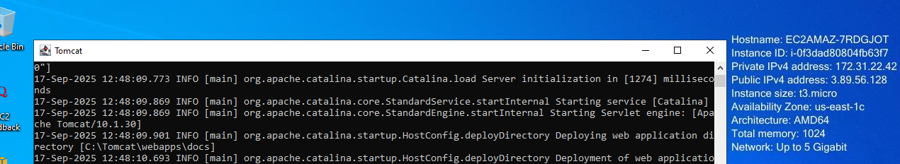

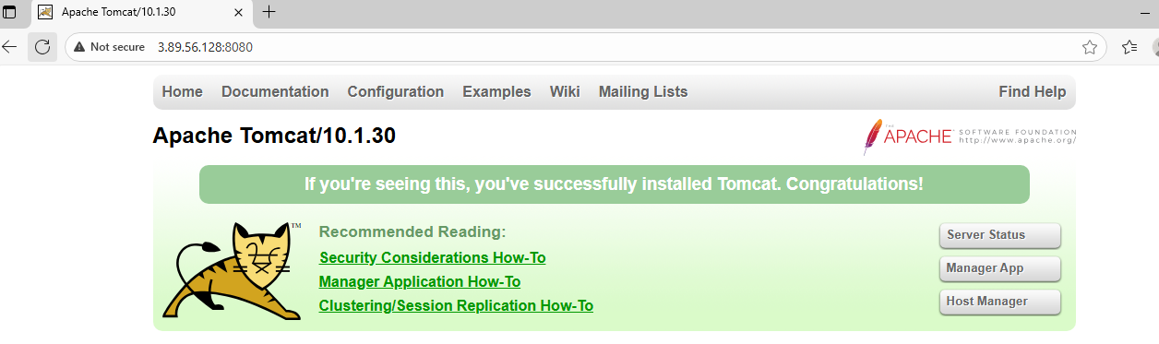

1. Take a snapshot of the instance created in Task 1.

**Instances → Select Instance → Storage tab → Block devices → Volume ID (click it).**

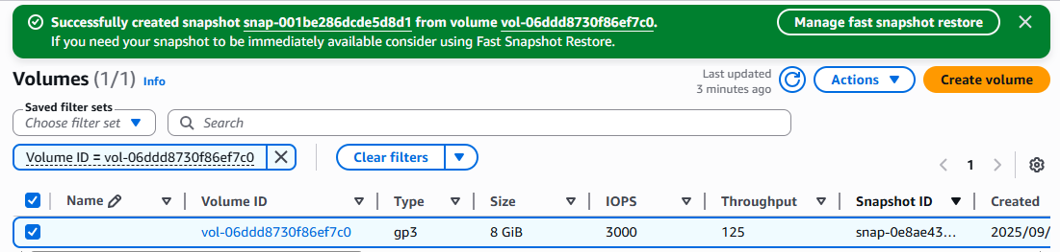

**Assign passwordless authentication for the EC2 created in Task 2**

**to create passwordless authentication:**

create a ssh-key in our local machine---ssh-keygen

then copy your public key using---cat /c/Users/DELL/.ssh/id_rsa.pub

launch an instance

create an user ---useradd techie

password for user---passwd techie

ssh-keygen---create a ssh key in ec2 machine

vi /root/.ssh/id_rsa.pub (paste your local machine key here by keeping

present key as same...

vi /etc/ssh/sshd_config----enable password authentication as yes

systemctl restart sshd---restart your sshd

now connect on your local machine:

ssh techie@public-ip

allow fingerprint authnetication:yes

enter password

hence you will be able to connect your instance

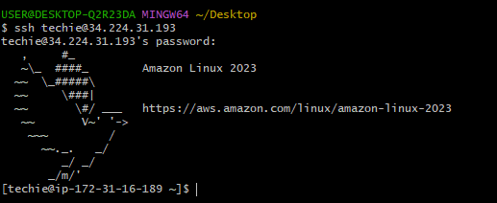

**Launch any EC2 using the spot purchasing option.**

• **Login to AWS Console** → go to **EC2 service**.

• Click **Launch instance**.

• Fill details:

* **Name**: (e.g., my-spot-instance)
* **AMI**: Amazon Linux 2023 (or your choice)
* **Instance type**: t3.micro (or other)
* **Key pair**: Select existing or create new key

• **In “Advanced details” → Purchasing option**

* Check ✅ **Request Spot instances**
* Choose **Interruption behavior** (Stop / Terminate / Hibernate)

• Configure storage, networking, and security group as needed.

• Click **Launch instance**.

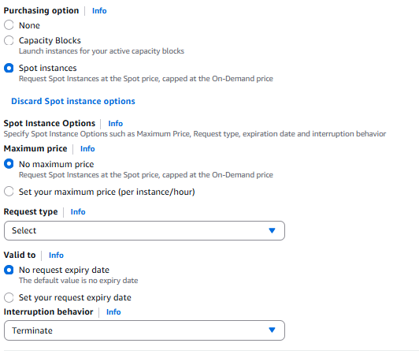

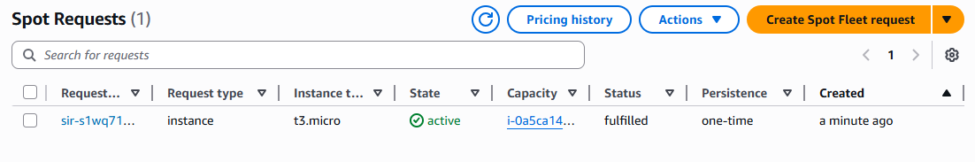

**Enable termination policy on the EC2 created in Task 2.**

**AWS Console:**

1. Go to **EC2 → Instances**.
2. Select your instance.
3. Click **Actions → Instance settings → Change termination protection**.
4. Turn it **ON**.

## Disable Termination Protection

### ✅ From AWS Console:

1. Go to **EC2 → Instances**.
2. Select your instance.
3. Click **Actions → Instance settings → Change termination protection**.
4. Switch it to **OFF**.

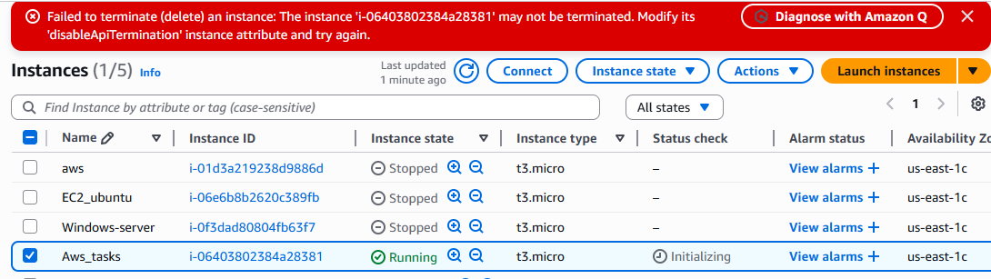

**Launch one EC2 using AWS CLI.**

